PIZZA SALES SQL QUERIES
A. KPI’s
1. Total Revenue:
SELECT SUM(total_price) AS Total_Revenue FROM pizza_sales1;
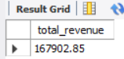
2. Average Order Value
SELECT (SUM(total_price) / COUNT(DISTINCT order_id)) AS Avg_order_Value FROM pizza_sales
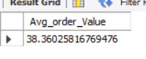
3. Total Pizzas Sold
SELECT SUM(quantity) AS Total_pizza_sold FROM pizza_sales
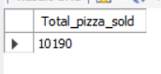
4. Total Orders
SELECT COUNT(DISTINCT order_id) AS Total_Orders FROM pizza_sales
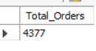
5. Average Pizzas Per Order
SELECT CAST(CAST(SUM(quantity) AS DECIMAL(10,2)) /
CAST(COUNT(DISTINCT order_id) AS DECIMAL(10,2)) AS DECIMAL(10,2))
AS Avg_Pizzas_per_order
FROM pizza_sales
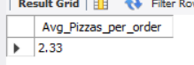
B. Daily Trend for Total Orders
select DAYNAME(STR_TO_DATE(order_date, '%Y-%m-%d')) as order_day , count(distinct(order_id)) as Total_order
from pizza_sales
WHERE order_date IS NOT NULL
group by DAYNAME(STR_TO_DATE(order_date, '%Y-%m-%d'));
Output:
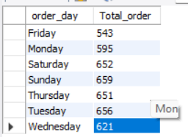
C. Hourly Trend for Orders
SELECT hour(order_time)as order_hours, COUNT(DISTINCT (order_id)) as total_orders
from pizza_sales
group by order_hours
order by order_hours
Output
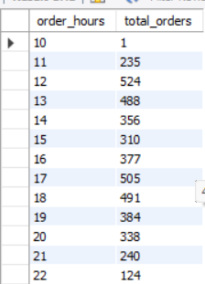
D. % of Sales by Pizza Category
select pizza_category ,sum(total_price)*100 / (select sum(total_price) from pizza_sales WHERE MONTH(STR_TO_DATE(order_date, '%Y-%m-%d')) = 1 ) as PCT , sum(total_price) as total_sales from
pizza_sales
WHERE MONTH(STR_TO_DATE(order_date, '%Y-%m-%d')) = 1
group by pizza_category;
#percentage of sales by pizza_category
Output
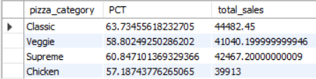
E. % of Sales by Pizza Size
select pizza_size ,cast(sum(total_price)*100 /
(select sum(total_price) from pizza_sales)
AS DECIMAL (10,2))as PCT ,
cast(sum(total_price) AS DECIMAL (10,2))as total_sales from
pizza_sales
group by pizza_size
order by PCT DESC;
#percentage of sales by pizza_size
Output
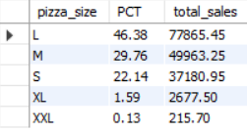

F. Total Pizzas Sold by Pizza Category
select pizza_category , count(quantity) as NPS from pizza_sales
group by pizza_category;
#CATEGORY WISE COUNT OF PIZZA SOLD
Output
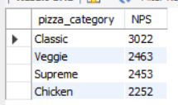
G. Top 5 Best Sellers by Total Pizzas Sold
SELECT pizza_name , sum(quantity) as No_of_PizzaSold from pizza_sales
group by pizza_name
order by No_of_PizzaSold desc limit 5;
Output
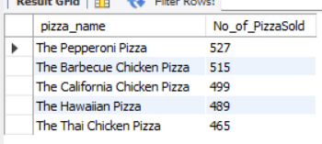

H. Bottom 5 Best Sellers by Total Pizzas Sold
SELECT pizza_name, SUM(quantity) AS Total_Pizza_Sold
FROM pizza_sales
GROUP BY pizza_name
ORDER BY Total_Pizza_Sold ASC limit 5;
Output
